OPEN_NEXT
Annexure
Deliverable 3.5
Finalised demonstrators - usability-tested, verified and validated demonstrators


This project is funded by the European Union’s Horizon 2020 Research and Innovation Programme under the Grand Agreement no. 869984.
OPEN_NEXT – Transforming collaborative product creation
Consortium:
# | Participant Legal Name | Short Name | Country
1 | TECHNISCHE UNIVERSITAT BERLIN | TUB | DE
2 | INSTITUT POLYTECHNIQUE DE GRENOBLE | GINP | FR
3 | ALEXANDER VON HUMBOLDT-INSTITUT FURINTERNET UND GESELLSCHAFT GGMBH | HIIG | DE
4 | UNIVERSITY OF BATH | UBA | UK
5 | ZENTRUM FUR SOZIALE INNOVATION GMBH | ZSI | AT
6 | FRAUNHOFER GESELLSCHAFT ZUR FOERDERUNG DER ANGEWANDTEN FORSCHUNG E.V. | FHG | DE
7 | DANSK DESIGN CENTER APS | DDC | DK
8 | WIKIMEDIA DEUTSCHLAND - GESELLSCHAFT ZUR FÖRDERUNG FREIEN WISSENS EV | WMDE | DE
9 | WIKIFACTORY EUROPE SL | WIF | ES
10 | STICHTING WAAG SOCIETY | WAAG | NL
11 | MAKER | MAK | DK
12 | AGILE HEAP EV | FLB | DE
13 | SONO MOTORS GMBH | SOM | DE
14 | OPNTEC GMBH | OPT | DE
15 | STYKKA APS | STY | DK
16 | TILL WOLFER | XYZC | DE
17 | FICTION FACTORY | FIF | NL
18 | M2M4ALL | SOD | NL
19 | INNOC OSTERREICHISCHE GESELLSCHAFT FUR INNOVATIVE COMPUTERWISSENSCHAFTEN | HAL | AT

Duration: 09/2019-08/2022
Grant: H2020-869984
Contact (coordinator): Prof Dr-Ing Roland JOCHEM
Address: Technische Universität Berlin, Sekretariat PTZ 3, Pascalstr. 8-9, 10587 Berlin
E-mail: roland.jochem@tu-berlin.de

Disclaimer: The contents of this document are not intended to replace consultation of any applicable legal sources or the necessary advice of a legal expert, where appropriate. All information in this document is provided "as is" and no guarantee or warranty is given that the information is fit for any particular purpose. The user, therefore, uses the information at his/her sole risk and liability. For the avoidance of all doubts, the European Commission has no liability in respect of this document, which is merely representing the views of the author(s).
D3.5 – „Finalised demonstrators - usability-tested, verified and validated demonstrators“

Review and approval status:
 | Name and Surname | Role in the Project | Partner
Author(s) | Martin Häuer;  Erik;  Cansu | Work Package Lead;  Research Associate;  Research Associate | IPK
 | Pen | Work Package Development | UBA
 | Max Kampik | Work Package Development | WIF
Reviewed by | xxx | xxx | xxx
 | xxx | xxx | xxx
Approved by | Robert MIES | Project Coordinator | TUB

History of changes:
Version | Date | Description of changes | By
0.1 | xxx | Initial draft | Martin Häuer
0.2 | xxx | Second draft version | Martin Häuer
0.3 | xxx | Draft for review | Martin Häuer
1.0 | xxx | Final document for final  project management  verification | Martin Häuer

Details:
Dissemination level | Open Access
Due date | 31.10.2021
Issue date | xxx
Contract No. | 869984
Responsible Partner | FHG
File name | D3.5_Validation of demonstrators.odt

Keywords:
Open source hardware, OSH metadata ontology, ICT for OSH, design reuse, open source development, distributed database, collaborative production
Table of Contents
>_1 Requirements Analysis 1
1.1 Sources for requirements 2
1.1.1 T2.3 | Requirements for design reuse 2
1.1.2 DIN SPEC 3105-1 | Requirements for Technical Documentation of Open Source Hardware 3
1.1.3 D3.1 | User stories 4
1.1.4 OKH | OSH Metadata Specification 7
1.2 Results 9
1.2.1 For the LOSH System 9
1.2.2 For the OKH-LOSH Specification and Ontology 14
1.3 Raw Data 17
>_2 RDF2WB-Converter 18
2.1 Design notes 19
2.2 Installation 20
2.3 Step-By-Step Example 20
>_3 LOSH-Frontend 22
3.1 Development Method 23
3.2 Design Notes 23
3.3 Specifications 27
3.3.1 Summary and Outlook 28
>_4 References 30

List of abbreviations and terms
API | Application Programming Interface
CAD | Computer-Aided Design
CE | Conformité Européenne (French for "European conformity")
DOI | Digital Object Identifier
FOSS | Free/Open Source Software
GNU | GNU’s Not Unix (recursive acronym)
JSON | JavaScript Object Notation (file format)
JSON-LD | JavaScript Object Notation for Linked Data (file format)
LOD | Linked Open Data
LOSH | Library for Open Source Hardware
OKH | Open Know-How
OKHv1 | Open Know-How Manifest Specification Version 1.0
OSH | Open Source Hardware
PCB | Printed Circuit Board
QR | Quick Response (used in the context of a matrix barcode (QR code))
RDF | Resource Description Framework
RDF2WB | Resource Description Framework to Wikibase
SME | Small and Medium-Sized Enterprises
SPARQL | Simple Protocol and RDF Query Language
STEP | Standard for the exchange of product model data (file format)
STL | Standard Tessellation Language (file format)
TsDC | Technology-specific Documentation Criteria
TOML | Tom's Obvious, Minimal Language (file format)
URL | Uniform Resource Locator

Table of Figures
Figure 1: Distribution of addressability of D3.1 user stories 5
Figure 2: Distribution of target group perspectives among addressable D3.1 user stories 5
Figure 3: Relative occurence of the metadata fields among analysed files 8
Figure 4: Detail view relative occurrence of the top 87 % of metadata fields used among analysed files 8
Figure 5: Log of a successful RDF ontology submission 21
Figure 6: “Data Explorer” page design – allowing for easy search and filter options 24
Figure 7: “Explore Data: Component Details” page design – detailed description of the selected specification 24
Figure 8: “Contribute specifications” page design – a step-by-step guideline on how to contribute specifications to the topic 25
Figure 9: “About our project” page design – explaining the background of the LOSH working group and our mission 26
Figure 10: “Ecosystem” page design – a description of the Open Source Hardware. 26
Figure 11: “Get involved” page design – a page to invite people to contribute to the project 27
Figure 12: LOSH frontend structure 27

Index of Tables
Table 1: Key findings for LOSH from the research carried out in T2.3 2
Table 2: File paths to raw data 17

LOSH Search

Search terms and results
During the user testing participants entered the following search terms:
- pinhole camera,
- washing machine,
- beehive,
- pcr,
- microscope,
- telescope,
- whistle,
- ship,
- gun.
For the heuristic analysis the top 10 search terms from the technology-neutral OSH search engine OHO.wiki have been used:
- cargo bike,
- corn mill,
- hot water collector,
- water turbine,
- brick machine,
- power hammer,
- lathe,
- water pump,
- lattice tower,
- concrete mixer.
Participants uploaded their search results into the survey. Please find the raw data in the upload folders in the folder “Export-LOSH-survey-all” in “raw data” attached to this report. The original list of top OHO search terms is included in the file “LOSH-search-heuristic-analysis.fods” as well as all exported search results in the folder “LOSH-search-heuristic-analysis” also in the folder “raw data”.

Analytical findings and suggested improvements
Free feedback from the workshop, survey comments or findings from the heuristic analysis were clustered and documented as technical issues on GitHub. During the analysis of the findings, the severity of issues and the potential value of suggested solutions has been rated on a scale from 1 (lowest) to 5 (highest). Table 1 shows a conclusion. The raw data can be found in the folder “GitHub-export“ in the folder “raw data” attached to this report.
Table 1: Overview of documented issues regarding LOSH search functions
Issue ID | Content | Type | Severity/Value | Comment | Source
118 | automatic content translation into most common languages used for European patents | feature request | 4 | improves accessibility of search results, specifically for patent attorneys | Community
120 | add counter for total search results | feature request | 3 | quick statistical information about how many OSH designs are available a) for a certain search term or b) on a specific platform | Heuristic analysis
121 | filter results for open file formats, identify | feature request | 4 | allows to quickly filter for modifiable designs and assess documentation readiness | Heuristic analysis
122 | download results only works for current page | bug report | 5 | download feature thereby practically broken for most users | User testing
123 | “results per page” sometimes not selectable | bug report | 2 | may result in an inconvenient view, but does not affect the search functionality | User testing
124 | order “repo hosts” by number of search results (omitting repo hosts without results) | feature request | 4 | would significantly increase the value of this filter function | User testing
125 | add thumbnails for the results on the search page | feature request | 4 | would allow for much faster assessment of relevance of search results | User testing
129 | “go to repo” of version-specific page always points to the latest version of the repository | bug report | 4 | feature essentially broken; likely causes confusion; however, does not break essential functions of the search functionality | Heuristic analysis
130 | “OSHWA” missing in “repo hosts” filter | bug report | 5 | important source of metadata not available through the filter | Heuristic analysis
137 | side crashes when searching for „lab“ | bug report | 5 | unknown cause; could happen for other search terms as well | Heuristic analysis
138 | Mostly unrelated results from page 3 onwards | bug report | 4 | search results include a large variety of irrelevant designs; the share of irrelevant results is almost equal to 1 after from page 3 onwards using any search term | Heuristic analysis
139 | no option for multiple filters nor filtering out | bug report | 5 | search results are flooded by thingiverse results, making it very hard to identify relevant results from other repo hosts | User testing
140 | versions or duplicates of the same hardware are not grouped or omitted | bug report | 5 | search results are flooded by duplicates or different versions of the same OSH design | User testing

As shown, the scores for severity/potential value are overall high. Most issues were very easy to identify and affected the usability and added value of the service directly, while some of these issues are connected. An example for this is issue #139: “no option for multiple filters nor filtering out” with a severity score of 5. As shown in Figure 1, search result pages contain a large variety of unrelated results (which is documented in issue #138). This latter issue could be mitigated if individual repository hosts (e.g. thingiverse) could be filtered out if those are found to be irrelevant for the performed search.
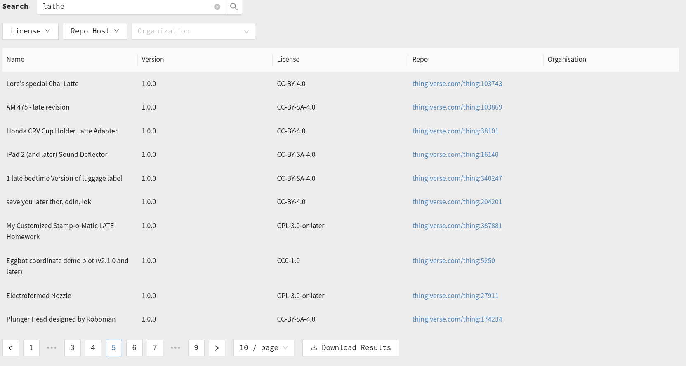Figure 1: Screenshot of irrelevant results when searching for "lathe"
Similarly, search results often include a quantity of duplicates or different versions of the same OSH designs, flooding the lists (issue #140). An example is shown in Figure 2 below.
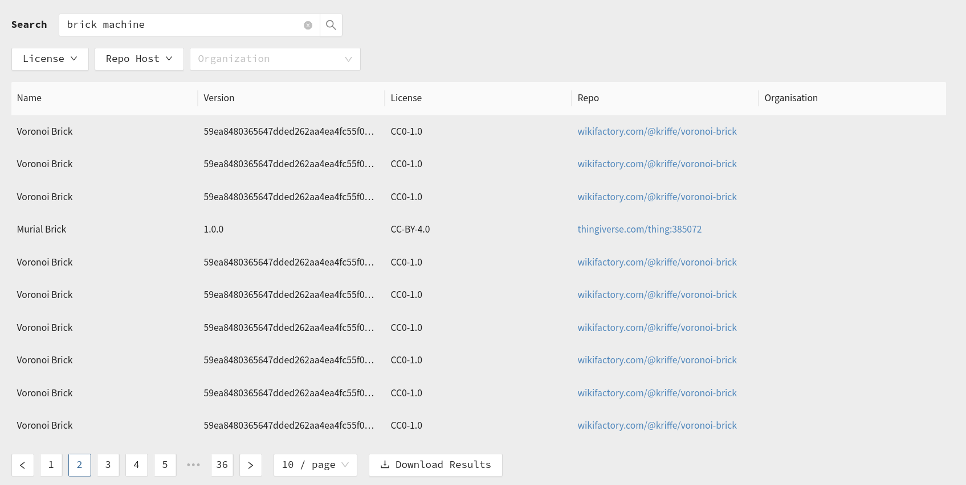Figure 2: Screenshot of duplicate entries when searching for "brick machine"

Summary and Outlook
xxx

References
[1] A. Ezoji, J. F. Boujut, and R. Pinquié, ‘Requirements for design reuse in open-source hardware: a state of the art’, Procedia CIRP, vol. 100, pp. 792–797, 2021, doi: 10.1016/j.procir.2021.05.042.
[2] J. Bonvoisin, J. Molloy, M. Haeuer, and T. Wenzel, ‘Standardisation of practices in Open Source Hardware’, arXiv:2004.07143 [physics], Apr. 2020, Accessed: Aug. 18, 2020. [Online]. Available: http://arxiv.org/abs/2004.07143
[3] ‘OSHWA Definition (English)’, Open Source Hardware Association. https://www.oshwa.org/definition/ (accessed Mar. 20, 2021).
[4] ‘DIN SPEC 3105-1:2020-07, Open Source Hardware_- Teil_1: Anforderungen an die technische Dokumentation; Text Englisch’, Beuth Verlag GmbH. doi: 10.31030/3173063.
[5] MakerNetAlliance, ‘OpenKnowHow’, StandardsRepo. https://app.standardsrepo.com/MakerNetAlliance/OpenKnowHow (accessed Sep. 21, 2021).
[6] MakerNetAlliance, ‘OpenKnowHow - YAML discussion’, StandardsRepo. https://app.standardsrepo.com/MakerNetAlliance/OpenKnowHow (accessed Sep. 21, 2021).
[7] Open Know-How Search - List of Manifest Files 10/2020. Open Know-How, 2021. Accessed: Sep. 21, 2021. [Online]. Available: https://github.com/OpenKnowHow/okh-search/blob/b9e7301f4e00b4021fa089822983ab36236bafee/projects_okhs.csv
[8] Hoijui, OPEN-NEXT/OKH-LOSH-YAML-stats: v1.0.0. Zenodo, 2021. doi: 10.5281/ZENODO.5534241.
[9] A. Narduzzo and A. Rossi, ‘Modular Design and the Development of Complex Artifacts: Lessons from Free/Open Source Software’, p. 40.
[10] ‘OpenKnowHow - Manifest Online Form’. https://okh.makernet.org/form (accessed Sep. 23, 2021).

